

**Department of Chemistry**

**Plantation Drive, Date: 2nd May, 2023**

**Report**

A plantation drive was organized by the Department of Chemistry, Integral University, on 2nd May, 2023. The activity was planned in compliance with the 2020 Agenda for Sustainable Development, adopted by all United Nations Member States in 2015. At its heart are the 17 Sustainable Development Goals (SDGs), which are an urgent call for action by all countries - developed and developing - in a global partnership. **The activity was aligned with the** **SDGs 13 and 15** respectively which talk about urgent actions which should be taken to combat climate change and conservation of life on land. The plantation was done in the corridor of the first floor of Academic block-D, around the Chemistry lab. About 70 students from different classes participated enthusiastically and potted saplings, particularly those which grow and nurture in shade. The activity was coordinated by Dr. Naseem Ahamd, Dr. Iqbal Azad and Dr. Tahmeena Khan from the Department of Chemistry.

**Glimpses of the Plantation Drive**

**Date: 2nd May, 2023**

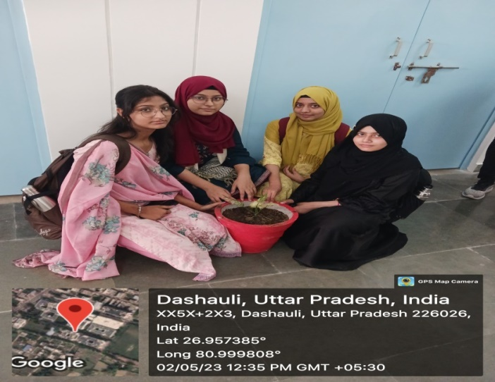 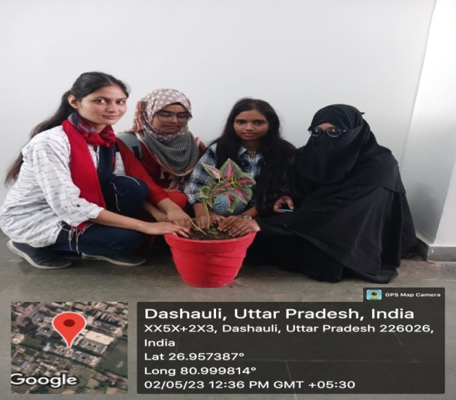

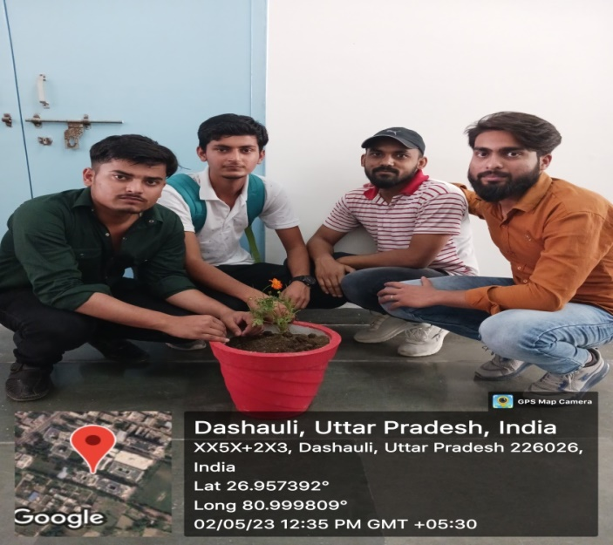 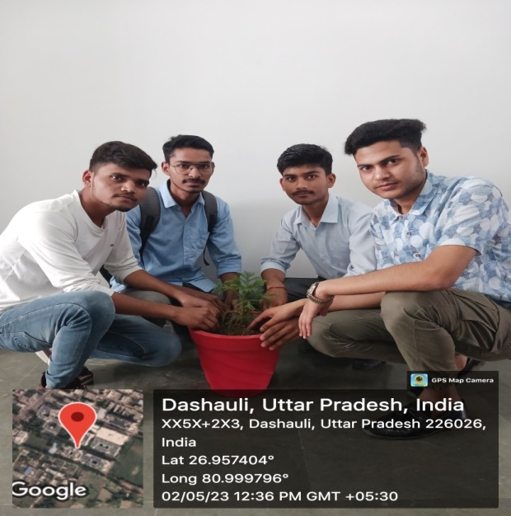

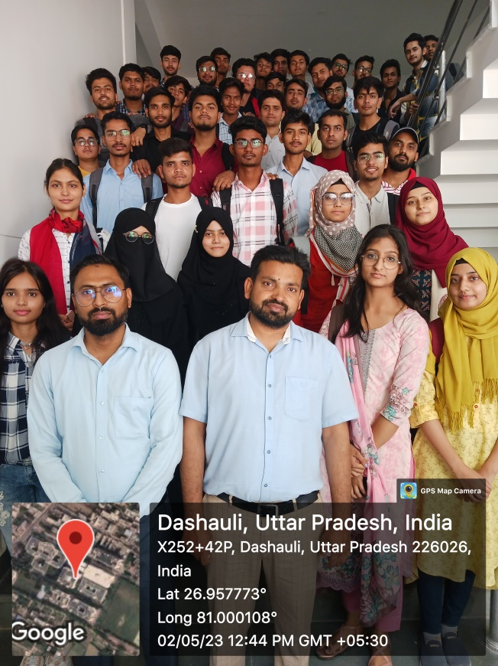

Submitted by

Dr. Tahmeena Khan